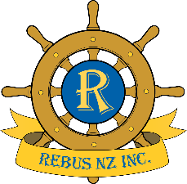

WHAT OUR MEMBERS SAY

- After losing my husband, I found myself on my own for the first time in my life. Apart from my family, I didn’t know anyone in the area. A Rebus member introduced me to the Club and it has truly changed my life. I have made friends and joined a variety of the Club’s social activities. I would encourage any active Retiree, whether single or with a partner, to come along and see for yourself, what Rebus has to offer.
Gwyneth.M

- I was a founding member of the Rebus Gulf Harbour Club, having been a member of the HBC Mens Rebus Club since 2012. I thoroughly enjoy the fellowship and special interest groups that Rebus offers. During my membership, I`ve been impressed by the wide range of skills and knowledge among members has added a valuable dimension to my retirement.
Pieter H.
- We joined Rebus Gulf Harbour soon after it was established in 2019. We have enjoyed making new friends and participating in activities such as Ramblers, City visits and bowling -outings we would not have undertaken on our own. Rebus has added a wonderful social dimension to our retirement
David and Verneice. K.

- After moving from the Coromandel to the Hibiscus Coast Village in 2020, we joined Rebus at Gulf Harbour to meet people beyond our immediate community. We have made many new friends and greatly enjoy the monthly meetings and activity groups. We consider our Rebus membership an excellent investment in time and money. Peter and Kathryn B.

